|  |
| --- |
|  |
| 新概念 3 册 |
| Lesson4 |

## Lesson 4 The double life of Alfred Bloggs

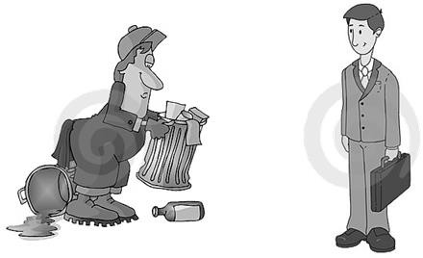

**词汇**

1. **manual ['mænjuəl] adj. 体力的**

manual work / labor 体力工作

反义：

**mental** 脑力的

**spiritual** 精神的 —— 反义词 **material** 物质的

**词根：**

**material “man(u)” = hand 手**

**manufacture 制造**

biscuit manufacturers 饼干制造商

soap manufacturers 肥皂生产商

**manacle 手铐**

**manuscript** 手稿

**emancipate 解放**

emancipate slaves 解放奴隶

the emancipation of women 妇女解放

the Emancipation Proclamation 废奴宣言

1. **collar** ['kɒlə(r)] **n. 衣领**

注意读音：

collar

above

Hi, buddy!

much

I love you, honey.

color

The color of the collar is white.

词组：

**white-collar workers** 白领

**blue-collar workers** 蓝领

The policeman **collared** the thief. （作动词）揪住

tie

tie a tie 系领带

**sigh** a sigh 叹口气

wish a wish 许个愿

I wished a wish on the star.

dream a dream 做个梦

die a **glorious** death

breathe one’s last breath

1. **sacrifice** ['sækrɪfaɪs] **v. 牺牲，献出**

sacrifice … for … 为了某个目的牺牲

Many women **sacrifice** their careers **for** their families.

Such is human nature, that a great many people are often willing to **sacrifice** higher pay **for** the privilege of becoming white-collar workers.

Relatively few people are prepared to **sacrifice** holiday time **for** the pleasure of travelling by sea.

指“放弃”

**give up**

**abandon**

abandon ship 弃船

**renounce** 表示正式宣布放弃

renounce smoking and drinking

**cede** 放弃领土

Hong Kong was **ceded** to Britain after the **Opium** War.

1. **privilege** ['prɪvəlɪdʒ] **n. 特权，特殊的好处**

**enjoy a privilege** 享有特权

**abuse a privilege** 滥用特权

Education is a **right**, not a **privilege**.

**have the privilege to do …** 荣幸做某事

Today, I **have the privilege to** speak at this important international forum on behalf of the Chinese government.

1. corporation [kɔ:pə'reɪʃn] **n. 公司**

**multinational corporation** 跨国公司

指“公司”

**company**

**firm**

**business**

**concern**

**enterprise**

foreign funded enterprise 外资企业

joint-venture enterprise 合资企业

state-owned enterprise (SOE) 国有企业

private enterprise 私营企业

township enterprise 乡镇企业

**课文**

1. These days, people who do manual work often receive far more money *than people who work in offices.*

时间状语“当今，现如今”：

**these days**

**today**

**nowadays**

**in** those days 想当初

指当今没有介词“in”

**In** those days, boxers fought with bare fists for prize money.

**In** those days wandering minstrels were welcome everywhere.

**receive money** 赚钱

make money

earn money

放在比较级前表“多的多”

**far / much / even / still / yet …**

放在比较级前表“多一点点”

**slightly / a little / a bit …**

**造句**：现如今，在娱乐界 (the entertainment field) 工作的人挣的钱往往比在教育行业 (the education sector) 工作的人多得多。

These days, people who work in the entertainment field often receive far more money than people who toil in the education sector.

1. People who work in offices are frequently referred to as 'white-collar workers' *for the simple reason that they usually wear a collar and tie to go to work.*

**anadiplosis** 顶真；连珠

一生二 二生三 三生万物

地法天 天法道 道法自然

天下文章数三江 三江文章数鄙乡

鄙乡文章数进士 进士跟我学文章

Our grief has turned to **anger**, and **anger** to resolution.

For glances beget ogles, ogles sighs, sighs wishes, wishes words, and words a letter.

If you dream it, you can do it;

if you do it, you can love it;

if you love it, you can enjoy it;

if you enjoy it, you can make it. (make it=succeed)

**refer to …** (to做介词) 提到……; 谈及……

= **mention** … / **speak of …**

Please don’t **refer to** this matter again.

**refer to A as** **B** 把A称为B

**call A B** 把A称为B

… and others will **call him ‘Mr. Bloggs’**, not Alf.

**address A as B** 把A称为B

美剧

Elizabeth: This is my father, Paul Stevens. Dad, this is Ross Geller.

Ross: It’s great to meet you Paul.

Paul: I usually prefer Elizabeth’s boyfriends to **address** me **as** Mr. Stevens.

Ross: Of course, of course, Mr. Stevens.

**know A as B** 把A称为B

He soon made a name for himself and came to be **known** to the Italians **as** Giovanni Acuto. Because of this, they were known **as** ‘prizefighters’.

He was **known** to us all **as** Dickie and his eccentricity had become legendary long before he died.

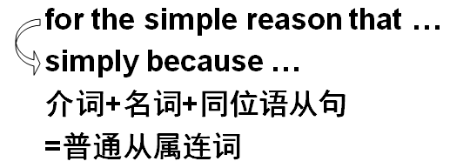

**表“因为”**

**for the reason that …**

**because of the fact that …**

**due to the fact that …**

**on account of the fact that …**

**= because …**

**表“尽管”**

**in spite of the fact that …**

**despite the fact that …**

**= although …**

**Despite the fact that** the bottle is tinted a delicate shade of green, an observant visitor would soon notice that it is filled with what looks like a thick, grayish substance.

**造句：**大熊猫常常被称为活化石 (living fossil)，只不过因为它们在世界上已经生存了两亿多年了。

Giant pandas are frequently referred to as ‘living fossils’ for the simple reason that they have lived on earth for over 200 million years.

1. Such is human nature, that a great many people are often willing to sacrifice higher pay for the privilege *of becoming white-collar workers*.

Such倒装，放在句首有强调的含义

原语序：Human nature is such that a great many people …

nature n. 本性、天性

Excuse me, **nature** calls.

He is kind by **nature**. 本性善良

**Such is human nature that …** 这是人之常情

It is human nature that …

**Such is human nature that** we all love to get something for nothing.

**Such is human nature that** we don’t treasure what we have until we lose it.

正常语序：

The conditions of society are such that skills have to be paid for in the same way that goods are paid for at a shop.

**Such are the conditions of society that** skills have to be paid for in the same way that goods are paid for at a shop.

**be willing to do** 乐意，愿意的

I shook my head and held up five fingers indicating that I **was willing to pay** ￡5.

**be ready to do** 乐意，愿意的

If your order is large enough we **are ready to reduce** our prices by 5%.

**be prepared for …** 准备好做

**be prepared to do** 乐意，愿意的

Why people **are prepared to tolerate** a four-hour journey each day for the dubious privilege of living in the country is beyond me.

**be unwilling to do** 不乐意做某事

**be reluctant to do** 不乐意做某事

Though he **was reluctant to do** so at first, we eventually persuaded him to take us.

**for the privilege of …**为了…好处

Why people are prepared to tolerate a four-hour journey each day **for the dubious privilege of** living in the country is beyond me.

1. This can give rise to curious situations, as it did in the case of Alfred Bloggs who worked as a dustman for the Ellesmere Corporation.

This can give rise to curious situations, as it did in the case of Alfred Bloggs who worked as a

dustman for the Ellesmere Corporation.

**give rise to sth.** (fml.) 导致……（正式表达）

The president’s absence **gave rise to** speculations about his health.

表“导致“的词组短语

cause

effect

result in

bring about

lead to

contribute to

account for

in the case of 示例

in case of ... 以免（不好的事情）会发生

in the event of ... 以免（不好的事情）会发生

**In case of / In the event of** bad weather, the wedding will be held indoors.

**注意**：**职务前用介词 as, 如果在某家公司工作，在公司前的介词用for,正式场合不用in和at**

I work **as** an English teacher **for** **New** Oriental School.

Thank you very much for having offered me such a golden opportunity to work **as** an editor **for** Designs & Fashions, a best-selling magazine renowned for its extraordinary quality and taste.

观点+例证

….（观点）, **as it did / does in the case of … who …**

This can cause curious situations. Alfred Bloggs was an example. He worked …

**造句:** 压力 (stress) 会导致精神上的一些疾病 (mental diseases), 正如在通用汽车公司

(General Motors) 工作的工程师 Mike Johnson 身上发生的情况一样。

Stress can give rise to mental diseases, as it did in the case of Mike Johnson who worked as an engineer for General Motors.

1. When he got married, Alf was too embarrassed to say anything to his wife about his job.

get married 结婚

marry sb. 娶了某人

be married to sb. 嫁给某人

The girl was married to me. 嫁给某人用介词 to

The girl was engaged to me. 与某人订婚用介词to

1. He simply told her that he worked for the Corporation.
2. Every morning, he left home dressed in a smart black suit.

**be (dressed) in …** 穿着….(被动结构)

He was (dressed) in a smart black suit. sb. wear sth.

He left home **wearing** a smart black suit. （主动结构）

注意：**主动被动一定由选定动词搭配决定，不能通过中文判断**

1. He then changed into overalls and spent the next eight hours as a dustman.

**Suit** 西装

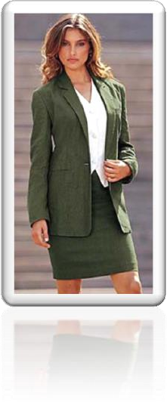

托福听力：

A. Take a lot of money.

B. Go to a different restaurant.

C. Don't invite John.

D. Wear different clothes.

Q: What does the man advise? Answer:

W: I'm taking John to that fancy new restaurant tonight.

M: You can't go like that. You'd better change.

(D) Wear different clothes. change (out of…) (into …)

换上这个，换上那个

**change** (**out of)… into….**

You’d better **change** **out of** the red jacket **into** a blue one.

表花费…

spend … on sth. / (in) doing sth

I **spent** a lot of money **on** food.

I **spent** a lot of time **on** homework.

I **spent** a lot of time **(in) learning** English. 表度过

I **spent** my summer vacation in Hainan Province.

I treasured every minute I spent with your family.

1. Before returning home at night, he took a shower and changed back into his suit.

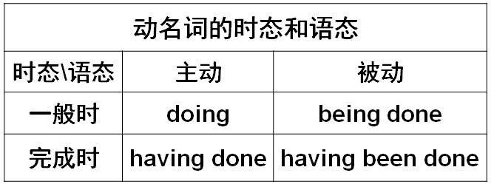

一般时：

After gazing at the display for several minutes, Mr. Taylor went back into his shop.

Four days after setting out, while the Titanic was sailing across the icy waters of the North Atlantic, a huge iceberg was suddenly spotted by a look-out.

主动完成时：

Ashamed of having acted so rashly, Dimitri apologized to Aleko for having accused him.

一般时被动：

Pretending to speak seriously, one of the workmen asked if he might make a telephone call before being taken to the station.

被动完成时：

After having been wounded towards the end of the war, he had been sent to hospital and was separated from his unit.

1. Alf did this for over two years and his fellow dustmen kept his secret.

**fellow** 表示身份和自己一样的人

fellow dustmen

fellow actors

fellow students

fellow citizens

fellow Chinese / Americans …

The gaoler looked on eagerly, anxious to see if his **fellow actor** had at last learnt his lines.

In so far as any inquiry is a secret one, it naturally limits all those engaged in carrying it out from effective contact with their **fellow scientists** either in other countries or in universities, or even, often enough, in other departments of the same firm.

We would lay less stress on 'facts and figures' and more on a good memory, on applied psychology, and on the capacity of a man to get along with his **fellow citizens**.

And so, my **fellow Americans**, ask not what your country can do for you; ask what you can do for your country. — John F. Kennedy

表“同事”

workmate

colleague

associate

One night, the gaoler decided to play a joke on his **colleague** to find out if, after so many performances, he had managed to learn the contents of the letter by heart.

1. Alf's wife has never discovered that she married a dustman and she never will, *for Alf has just found another job.*

I was, am and **will be** your friend. 我过去是，现在是，将来也会是你的朋友。

1. He will soon be working in an office.

**will be doing** 表达一种可预见性

Professor Wang **will be taking** charge of our department next Monday.

1. He will be earning only half **as** much **as** he used to, **but** he feels *that his rise in status is well worth the loss of money.*

**第一个as是副词，第二个是连词，引导比较状语从句**

He will be earning only half **as much as** he used to (earn), …

**英语中表达倍数的三种方式：**

**1.A is … times as … as B**

**2.A is … times the amount(数量，不可数) (the number(数量，可数), the size(大小), the length(长度), the width/breadth(宽度), the height(高度), the value(价值), the price(价格), etc.) of B**

**3.A is … times 比较级 than B** 表倍数

**举例：他的工资是我的三倍。**

His salary is **three** times as much as mine.

His salary is **three** times the amount of mine.

His salary is **twice** more than mine. （多两倍）

**举例：这个箱子是那个箱子四倍大。**

The box is **four** times as big as that one.

The box is **four** times the size of that one.

The box is **three** times bigger than that one.

**worth 当作介词好一些**

**worthy 形容词**

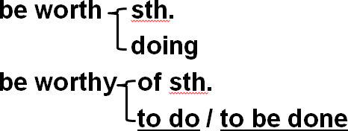

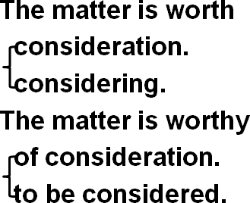**举例：**

The day when Beijing won the right to host the 2008 Olympic Games is worth being celebrated. 表达错误 be worth 后面不能接被动

改正：The day when Beijing won the right to host the 2008 Olympic Games is worth celebration / celebrating. √

The day when Beijing won the right to host the 2008 Olympic Games is worthy of celebration / to be celebrated. √

1. From now on, he will wear a suit all day and others will call him 'Mr. Bloggs', not 'Alf'.

call sb. names 脏话

Stop calling my father names!